CMPT 365 Written Assignment 1

Junchen Li

301385486

2021/2/11

**Section 1.5**

**Q5**  Discover a current media input, storage, or playback device that is analog. Is it necessary to convert to digital? What are the pros and cons of being analog or digital?

Answer: The most popular digital media input is the turntable; we call it as record player as well. The stylus in the record player continuously reads the bumps and grooves on the record to make different sounds. It does not necessarily have to be converted into digital form. Of course, the digital record player is also a well-known cd player. Now more and more people like to collect records, because of the analog signal has a higher density and can provide more detailed information, giving people an immersive sense of time travel. Although digital audio can sample analog signals at a high frequency per second, it is far from being as accurate as digital signals. So it is not necessary.

As mentioned above, analog signals have higher density and can provide finer information. It also processes better than digital signals. The disadvantage is also obvious; the analog signal is prone to loss. In contrast to digital signals with higher noise immunity, analog signals are susceptible to noise and distortion and tend to be of lower quality than digital signals. Taking the above example, the production of a record will be mechanically transmitted, but often the mechanical transmission will be affected by the environment, temperature, and gravity. If the master tape is reproduced, the loss will become greater and greater.

Digital data is easier to manage, edit, copy and save. Since computers only process digital data, most information today is stored digitally. Although the sound quality processing cannot reach the point of losslessness, the loss is negligible if the sampling rate is high enough to exceed the hearing range of the human ear

**Section 6.4**

**Q1** We wish to develop a new Internet service, for doctors. Medical ultrasound is in the range 2-10 MHz; what should our sampling rate be chosen as?

Answer: For the correct sampling we must use a sampling rate at least twice of the max frequency content in signal. So we should choose the sampling rate of $10 × 2=20$ MHz.

**Q2** My old Sound blaster card is an 8-bit card.

1. What is it 8 bit of ?
2. What is the best SQNR (signal-to-quantization-noise ratio) it can achieve?

Answer: a) This 8-bit represents the quantum level of the old Sound Blaster card. Quantization replaces each discrete time with an approximation of a finite set of discrete values. The most common word length in many quantization levels is 8 bits. Although the larger the number of quantization levels, the more accurate the digital representation, but too much quantization is wasted in terms of time required.

b) The SNR calculating equation is $10\log_{10}{\frac{{V^{2}}_{signal}}{{V^{2}}_{noise}}}$. Follow the slide for a quantization accuracy of N bits per sample, the peak SQNR can be simply expressed:

SQNR = $20\log_{10}{\frac{V_{signal}}{V_{quan-noise}}}=20\log_{10}{\frac{2^{N-1}}{\frac{1}{2}}}=20×N×log2≈6.02N(dB)$. Since we know the formula and we try to find the 8 bit. The best SQNR (signal-to-quantization-noise ratio) it can achieve is 6.02*8 = 48.16 (dB).

**Q4** If a set of ear protectors reduces the noise level by 30 dB, how much do they reduce the intensity (the power)?

Answer: The power if SNR equation is $10\log_{10}{\frac{{V^{2}}_{signal}}{{V^{2}}_{noise}}}$. Since we know the reduce

noise level is 30 dB. $10\log_{10}{\frac{{V^{2}}_{signal}}{{V^{2}}_{noise}}}=30 3$

$\log_{10}{\frac{{V^{2}}_{signal}}{{V^{2}}_{noise}}}=3$

$\frac{{V^{2}}_{signal}}{{V^{2}}_{noise}}={10}^{3}=1000$

$$∴The reduce the intensity is 1000$$

**Q8** The dynamic range of a signal V is the ratio of the maximum to the minimum expressed in decibels. The dynamic range expected in a signal is to some extent an expression of the signal quality. It also dictates the number of bits per sample needed in order to reduce the quantization noise down to a acceptable level, e.g., we may like to reduce the noise to at least an order of magnitude below $V_{min}.$

Suppose the dynamic range for a signal is 60 dB. Can we use 10 bits for this signal? Can we use 16 bits?

Answer: Follow the slide, we can map the max signal to $2^{N-1}-1\left(≅2^{N-1}\right) and the most negative signal to {-2}^{N-1}.$ For the dynamic range, the ratio of max to min abs value is $\frac{V_{max}}{V_{min}}$. For the quantization interval, qi = $\frac{(2×V_{max})}{2^{N}}/2$ since the most negative signal - $V_{max}$ is mapped to $-2^{N-1}.$ The standards of this question is the dynamic range for signal is 60 dB. Put into equation, $20\log_{10}{ratio of\max{and\min{=20\log_{10}{\frac{V_{max}}{V_{min}}=60. ->\frac{V_{max}}{V_{min}}=1000 }}}}.$ The 10 bits’ situation, $\frac{V_{max}}{2^{10}}$ and for 16 bits’ situation, $\frac{V_{max}}{2^{16}}$. The first one $2^{10}=1024$ is not sufficient the intensity resolution bur for the second one, it can sufficient the range of $V_{max} and V_{min}$. So we can use the 16 bits for this signal.

**Q 12** State the Nyquist frequency for the following digital sample intervals. Express the result in Hertz in each case.

1. 1 millisecond
2. 0.005 s, and
3. 1 h

Answer: The Nyquist theorem is the twice of the lower limit $f_{1}$ and an upper limit $f_{2}$ of frequency components in the signal. The ratio of Nyquist frequency and the sample period is 1 millisecond will have 500 Nyquist frequency. The unit for Nyquist frequency is (Hz). $\frac{millisecond}{500}$

|  |  |  |
| --- | --- | --- |
| Input | Millisecond (ms) | Nyquist frequency (Hz) |
| 1 millisecond | 1 | 500 |
| 0.005 s | 5 | 500/5 = 100 |
| 1 h =3600s | 3600000 | 3600000/500 = 1.3889 $×{10}^{-4}$ |

The data resource is based on https://www.sciencedirect.com/topics/earth-and-planetary-sciences/nyquist-frequency

**Section 4.4**

**Q 8** a) Suppose image are not gamma-corrected by a camcorder. Generally, how would they appear on a screen?

1. What happens if we artificially increase the output gamma for stored image pixels? (One can do this in Photoshop.) What is the effect on the image?

Answer: a) If the image is not gamma-corrected by a camcorder, for different configurations of the display device, there will be different rendering (light dark). When imported into Photoshop, the overall image will appear darker. Because of the light output from CRT with no gamma-correction and darker values are displayed as too dark.

b) The relationship between RGB value and power is not a simple linear relationship, but a power function relationship. If we increase the output gamma of the stored image pixels for ground. This will increase the number of bright pixel blocks even more. Make the overall picture brighter instead of darker before correction.

**Q 9**  a) Comment (very roughly) on the effect of this operation on the number of actually available levels for display.

Hint: coding this up in any language will help you understand the mechanism at work better – and as well, then you can simply count the output levels.

(b) Which end of the levels 0..255 is affected most by gamma correction, the low end near 0 or the high end near 255? Why? How much at each end?

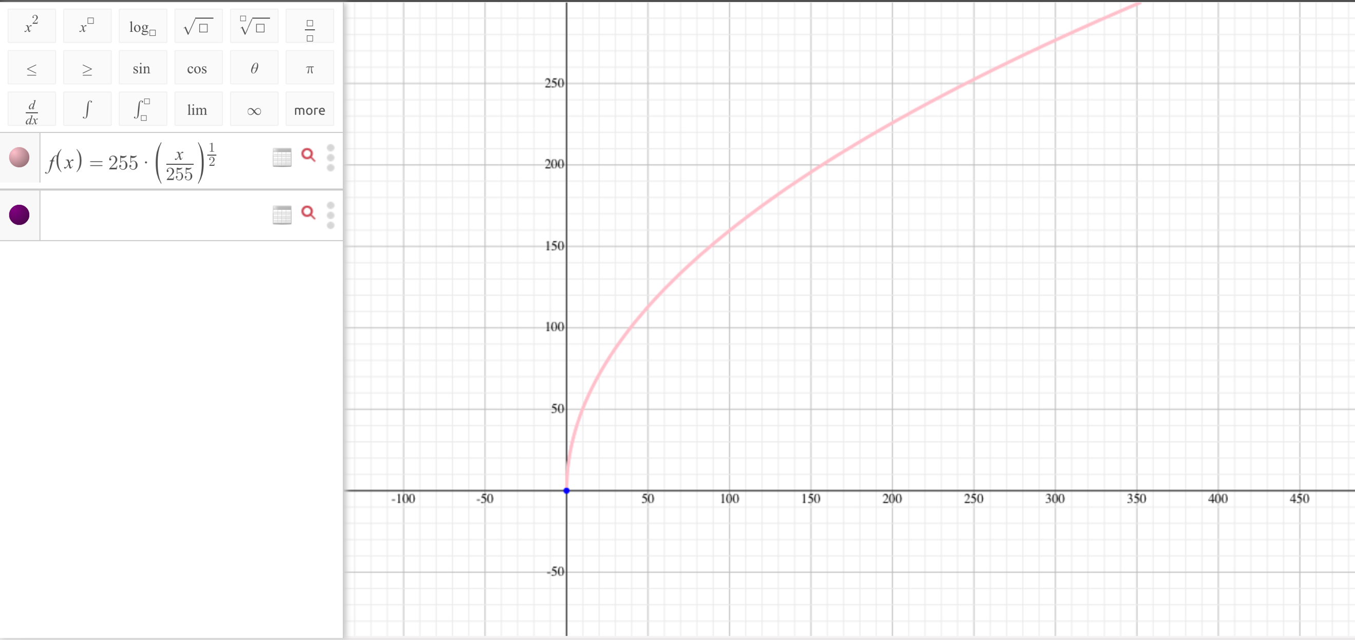Answer a) The integer values actually taken can not exceed the range between 0 and 256. And we plot the $255*{(\frac{R}{255})}^{\frac{1}{2}}$ as the follow:

Since the original version will start at 0 to 255, but after this operation we will have one more level. We can notice from the plot that the left-hand side converges very quickly. When we rounding the result, we could lose some part of value. So the number of actually available levels for display will decrease.

1. Put the value 0 and 255 for the start and end into the equation $255*{(\frac{R}{255})}^{\frac{1}{2}}$. For the R1=0, the result still the 0 and for R2 = 255, the result is 255. However, if we put the R1+1=0+1=1 put into the equation, we could get roughly 15.97. If we put R2-1 = 255-1=254 into the question, we still can get roughly 254.499. So which means the lower end will have more affected than the higher end.

**Ex1:** Assume that a PC has a working noise of 50 dB. What will be the working noise of 5 such PCs? What about 10 such PCs?

Answer: The one PC will have a working noise of 50 dB. In the formula, $20\log_{10}{\frac{V_{signal}}{V_{noise}}=50}$. If we have the 5 such PCs, the total noise value will keep the same but the signal will increase five times. So in the 5 such PCs situation, $20\log_{10}{\frac{{5* V}_{signal}}{V_{noise}}=20(\log_{10}{\frac{V_{signal}}{V_{noise}}+\log_{10}{5}})}$ We factor out the 5 by the log formula. 0.69897*20+50 $≅63.9794(dB)$. The same procedure for the 10 such PCs.

$20\log_{10}{\frac{{10* V}_{signal}}{V_{noise}}=20(\log_{10}{\frac{V_{signal}}{V_{noise}}+\log_{10}{10}})}=20+50=70(dB)$. So for the 5 such PCs, the working noise is roughly equal to 63.9794 dB and for such 10 PCs, the working noise is equal to the 70 dB.

**Ex2:** Assume that a camera’s CCD sensor has some error in capturing colors. Basically, its R becomes (real) R/2+G. Design a matrix that correctly converts its captured R, G, B to the real Y, U, V.

Answer: The R becomes R/2+G, so we though it will be the “normal” one. The real matrix is $\begin{matrix}0.299 & 0.587 & 0.114 \\ -0.299 & -0.587 & 0.886 \\ 0.701 & -0.587 & -0.114\end{matrix}*[\begin{matrix}R \\ G \\ B\end{matrix}]$ Now the R change to the $[\begin{matrix}\frac{R}{2}+G \\ G \\ B\end{matrix}]$

In theory, if we want to transform to the correct Y U V, the modify matrix should be

$\begin{matrix}1.196 & 2.348 & -1.484 \\ -0.299 & -0.587 & 0.886 \\ 0.701 & -0.587 & -0.114\end{matrix}$. If we want to get the correct result without affecting by the wrong R, before multiple them, the first do –G and *2. After that, the Y result will have out-of-range output, because this is us modify matrix for incorrect R input. And the correction can not be the perfect.

**EX3:** List three multimedia applications that were launched in recent five years. For example, TikTok, social media sharing platform for short videos, 2017

Answer:

1. Discord, it is an instant messaging and video or voice call service using for gaming community or working, educational purpose. The first original version is in March 6th in 2015.
2. Beme, a vlogger and short film maker on YouTube and developed by Beme Inc. The first version of Beme was launched on July 17, 2015 for iOS. On May 2, 2016, an Android version was released
3. Dingding, Multi-terminal platform for free communication and collaboration, supporting video conferencing and file exchange. The official version was released in May 26th, 2015